Run : "regedit"

GO TO: Computer\HKEY_CLASSES_ROOT\Directory\Background\shell\

mouse 2 on "shell" => new -> key :(name whatever you want)

mouse 2 on above step => new -> key "command"

paste run path

~~~~~~Done!!

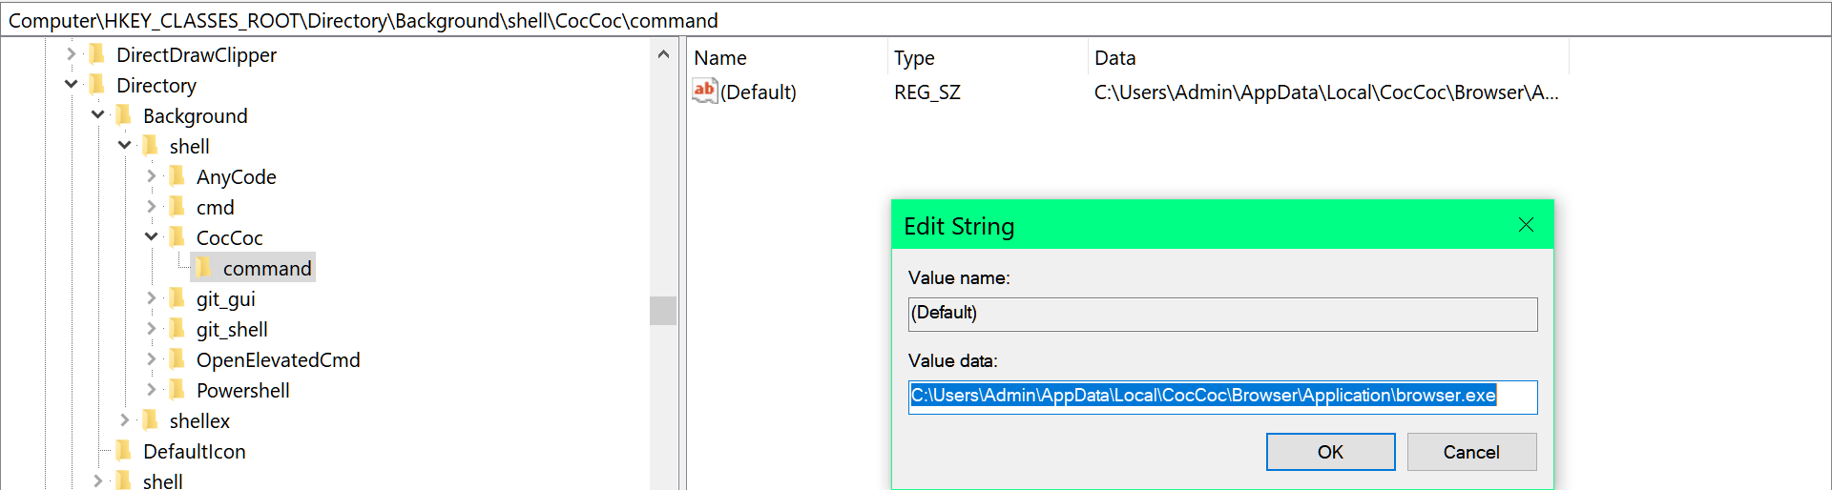

Add quick directory shortcut

